# Operation Report

1)

**a.** 167

*Decision Variable*: quantity

*Object Function*: profit = (price – variable cost)*quantity – fixed cost

By using excel “Goal Seek” object function profit = 0

b.

Use Excel “Data Table”, column reference selects “quantity” (in B8).

Quantity sold has a positive linear relationship with profit sold (see graph in d). Use James’s estimate, 500 quantity sold, as base line, 10% variation implies 15% variation in profit. In other words, if quantity sold were reduced by 10% profit would reduce by 15%. Quantity reducing by 67% (as table implies) fully delimitate profit.

**c.**

Generated by Excel “Data Table”.

**d.**

**e.**

2)

**a.**

Additive implies the cost are fixed to a certain amount. Proportionality assumptions implies costs variate to quantity given to a fixed proportion.

**b.**

When mathematical model consider quantity has affects other variables that is

For example, crude oil producer may consider the effect that more production (supply) may reduce oil price. Assume oil price is a linear quantity produced, objective function would still be non-linear because revenue is a production of quantity and price, and quantity will double its effect on revenue quantically.

**3)**  
**a.**

Since chemical is constrained to 4000 units.

D­superman *4 + Dbat man *3 ≤ 4000

Dsuperman *4 + Dsuperaman *3*3 ≤ 4000

Dsuperman ≤ 307.7

Since demand has to be an integer, the maximum demand of superman is 307. Consequently, profit is:

*profit* = Dsuperman * 40 + Dsuperman * 3* 25

= 35305

**b.**

*Decision Variable*: demand of Superman (since demand of Superman is to a proportion of Batman, set Superman also set demand for all)

*Objective Function*: profit function to demand of superman, express as:

*profit* = Dsuperman * 40 + Dsuperman * 3* 25

*Constraints*: chemical usage below 4000 and demand is integer.

Optimal profit is 35305

**c.** Shadow price 8.85; however, pay higher price for a limited litre of chemicals:

Based on model in b, set price of chemical as a *Decision Variable* instead. Let the profit deduct cost of chemicals.

Use Excel “*Goal Seek*” to find price that set profit to 0:

Find *shadow price* £8.85, this implies:

To obtain extra chemicals, price *Toyzfactory* can pay cannot exceeds £8.85 on top of the chemical’s current price. This assumes demand for those toys are infinite ( all toy produced can be sold).

However, *Toyzfactory* can purchase the next 4 extra litres for a price no higher than £28.75:

If 4000 litres of chemical were purchased, 9 litres left would not be enough to make a mix of 1 Superman toy and 3 Batman toys. To make a mix requires total 13 litre of chemicals ( 1*4 + 3*3 = 13). So, an extra of 4 litre needs to be purchased. 13 litre of chemical can generate marginal profit of £115.0 (13*8.846). Marginal profit deduct by 4 litre is £28.75 per litre (see concept graph on the left).

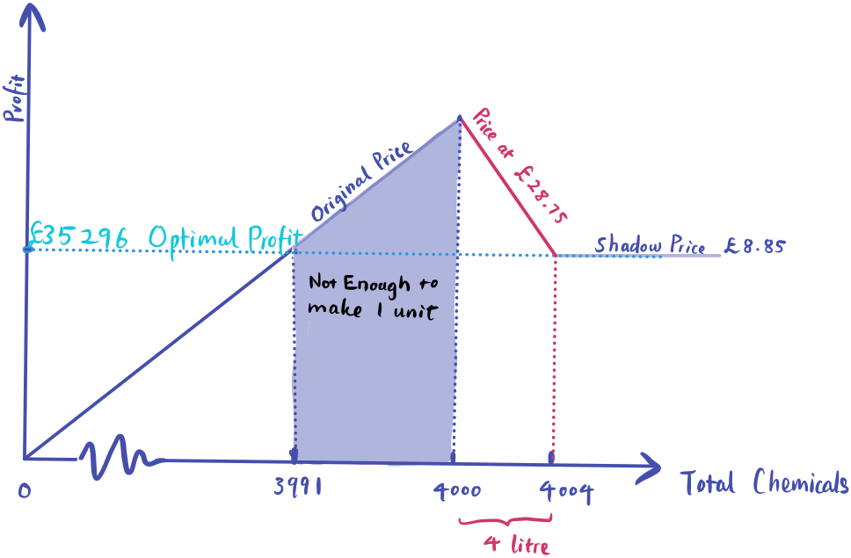

Relationship between chemical usage and profit. Slope of the line are affected by different chemical price.

**d.** Do not lose profit before until lost 9 litter chemicals, for every litter of chemical lost lose about 8.846 profit.

**4)**

**a.**

**Decision Variable**:

The goal is to find production mix for the two types of vaccines. For the propose of building objective function, one can set two decision variables:

* Production quantity of traditional vaccine (type 1)
* Production quantity of the mRNA vaccine (type 2)

***Objective function***:

Since the company’s objective is to maximize profit, a production-profit formular is required. In general, this requires 3 components. Marginal contribution, production quantity, fixed cost. Unit contribution express both price and variable cost. Management must determine price of the two products however through market mechanism or other means. Costing department can compute variable costs. Fixed costs should include cost that does not change with quantities. Typical fixed cost in this case maybe cost relevant to research and development (R&D).

Once those information are found one can list algebra expression of the objective function.

Over production is undesirable. Especially, mRNA vaccine requires ultra-cold storage which consumes more inventory costs. If the time from a vaccine being produced to sold took too long it will start generating cost.

**b*. Constraints***:

Lower-bound constraints:

* *Non-negative constraints*: vaccine quantity cannot be negative thus non-native constraints apply.
* *Pre-order/contact*: vaccines that has been pre-ordered by government or under investment contract.

Upper-bound constraints:

* *Production constra*ints: the usual production constraints for two vaccines:
  + Staff total working hours
  + Raw material viable in a given time
* *Logistic threshold*: since some vaccine production have over-sea operations, the logistic capacity in a given time may limit the amount of vaccine shipped to US.
  + Ultra-cold chain: mRNA vaccine requires ultra-cold facilities. Since a limited amount of ship have freezing facilities, special case applies to the type
* *Demand constraints*:
  + *Anti*-vaccine sentiment: as enlisted by Danner and Stieb (2020), the anti-vaccine sentiment may lead to many vaccines produced not accepted by the general public.
  + Vaccine administration: since the pharmacy company administrate vaccine. The amount of vaccine can be administrated may be another limit.
  + Government policy: Government may purchase limited amount of vaccine due to budget limit